Oblique Plane
# Source: AI Source: Provided by: [Data Path: Persons Table -> ID Column: 1, Name_En Column: Motasem Essam] -> From: [ChatGPT] on [7/25/2026]
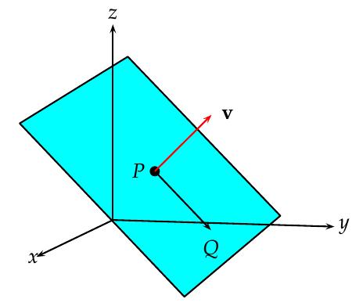
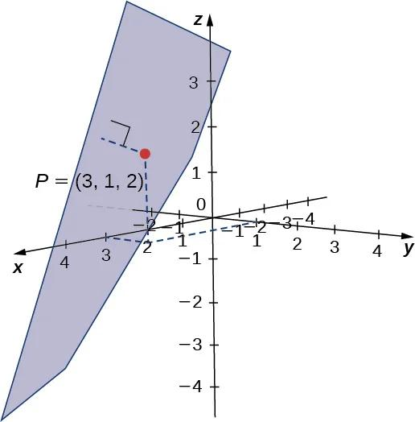
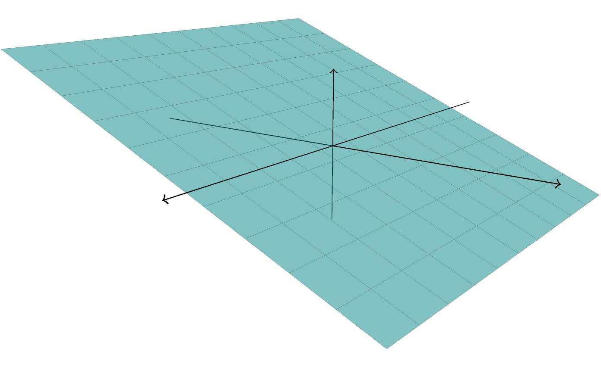
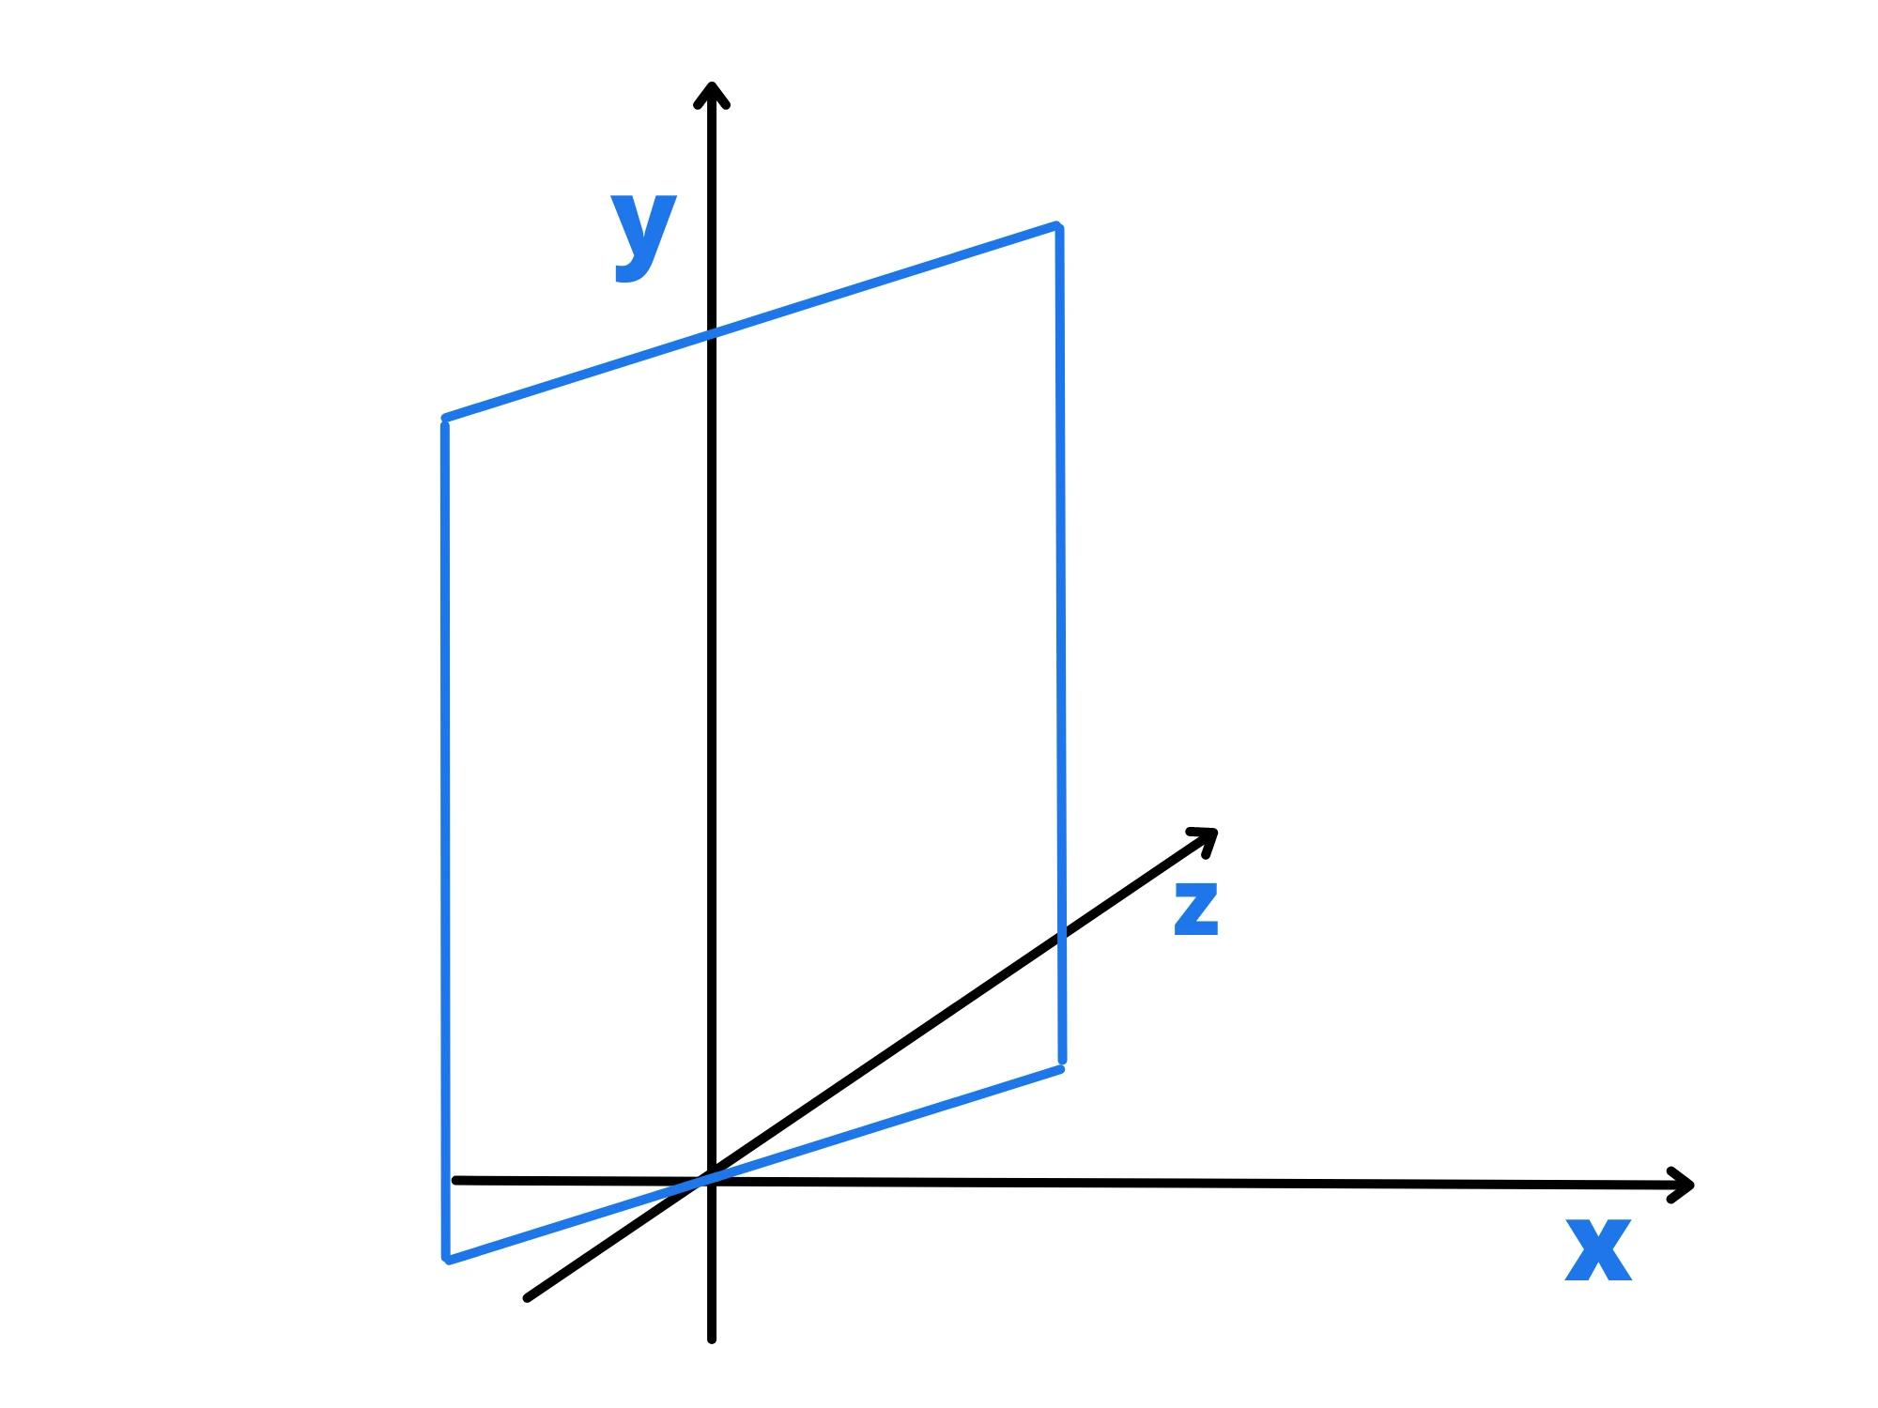
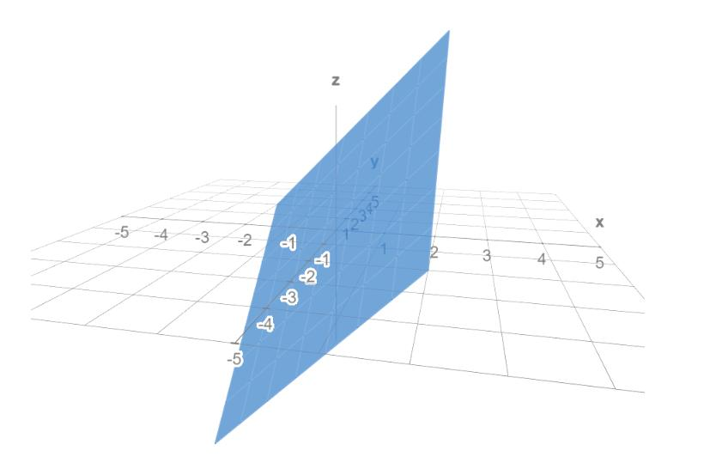
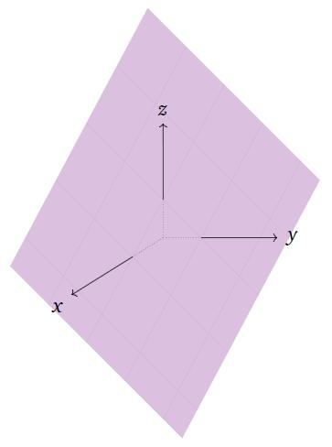

Definition
# Source: AI Source: Provided by: [Data Path: Persons Table -> ID Column: 1, Name_En Column: Motasem Essam] -> From: [ChatGPT] on [7/25/2026]
An Oblique Plane is a plane that is neither horizontal nor vertical. It is inclined at an angle to the horizontal plane and is not perpendicular to it.
Unlike a horizontal plane, which remains level, or a vertical plane, which stands upright, an oblique plane is slanted in space.
In three-dimensional coordinate geometry, an oblique plane is generally represented by:
$$Ax+By+Cz+D=0$$
where $A$, $B$, and $C$ are all nonzero (in the general case), meaning the plane is not parallel to any coordinate plane.

Characteristics
# Source: AI Source: Provided by: [Data Path: Persons Table -> ID Column: 1, Name_En Column: Motasem Essam] -> From: [ChatGPT] on [7/25/2026]
An oblique plane:
- Is inclined relative to the horizontal plane.
- Is not vertical.
- Is not horizontal.
- Extends infinitely in all directions within the plane.
- Can intersect all three coordinate axes.
- Has a normal vector pointing in an arbitrary direction.

Illustration
# Source: AI Source: Provided by: [Data Path: Persons Table -> ID Column: 1, Name_En Column: Motasem Essam] -> From: [ChatGPT] on [7/25/2026]
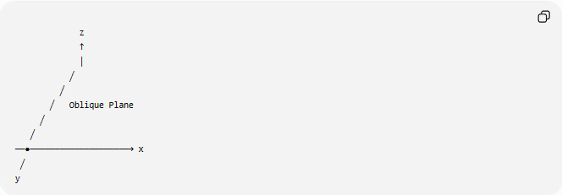
z
↑
│
╱
╱
╱ Oblique Plane
╱
╱
──●────────────────────→ x
╱
y
The plane is tilted and does not align with any principal coordinate plane.

Mathematical Representation
# Source: AI Source: Provided by: [Data Path: Persons Table -> ID Column: 1, Name_En Column: Motasem Essam] -> From: [ChatGPT] on [7/25/2026]
General Equation
An oblique plane is written as:
$$Ax+By+Cz+D=0$$
where:
- $A$, $B$, and $C$ are constants.
- $D$ is a constant.
- At least one coefficient is nonzero.
- For a typical oblique plane, all three coefficients are nonzero.

Example 1
$$2x+3y-z+5=0$$
This plane is oblique because it is neither:
$$x=c$$
nor
$$y=c$$
nor
$$z=c$$

Example 2
$$x+y+z=6$$
This plane intersects the three coordinate axes and is an oblique plane.

Position in the Coordinate System
# Source: AI Source: Provided by: [Data Path: Persons Table -> ID Column: 1, Name_En Column: Motasem Essam] -> From: [ChatGPT] on [7/25/2026]
In three-dimensional space:
- Horizontal plane:
$$z=c$$
- Vertical plane:
$$x=c$$
or
$$y=c$$
- Oblique plane:
$$Ax+By+Cz+D=0$$
with no alignment to the principal coordinate planes.

Properties
# Source: AI Source: Provided by: [Data Path: Persons Table -> ID Column: 1, Name_En Column: Motasem Essam] -> From: [ChatGPT] on [7/25/2026]
1. Infinite Extent
Like all planes, an oblique plane extends infinitely.

2. Arbitrary Orientation
Its orientation depends on its normal vector:
$$n=\left\langle A,B,C\right\rangle$$

3. May Intersect Coordinate Axes
An oblique plane often intersects:
- the $x$-axis,
- the $y$-axis,
- the $z$-axis.

4. Can Divide Space
The plane divides three-dimensional space into two half-spaces.

Real-World Examples
# Source: AI Source: Provided by: [Data Path: Persons Table -> ID Column: 1, Name_En Column: Motasem Essam] -> From: [ChatGPT] on [7/25/2026]
Oblique planes appear in:
- Sloped roofs.
- Hillsides.
- Ramps.
- Inclined walls.
- Aircraft wings.
- Mountain faces.
- Solar panels.
- Escalators.

Applications
# Source: AI Source: Provided by: [Data Path: Persons Table -> ID Column: 1, Name_En Column: Motasem Essam] -> From: [ChatGPT] on [7/25/2026]
Oblique planes are used in:
- Analytic Geometry
- Coordinate Geometry
- Engineering
- Architecture
- Civil Engineering
- Mechanical Engineering
- Surveying
- Computer Graphics
- CAD (Computer-Aided Design)
- Robotics
- Physics

Advantages
# Source: AI Source: Provided by: [Data Path: Persons Table -> ID Column: 1, Name_En Column: Motasem Essam] -> From: [ChatGPT] on [7/25/2026]
Studying oblique planes helps to:
- Model inclined surfaces.
- Describe real-world structures.
- Analyze three-dimensional geometry.
- Compute intersections.
- Solve engineering problems.

Limitations
# Source: AI Source: Provided by: [Data Path: Persons Table -> ID Column: 1, Name_En Column: Motasem Essam] -> From: [ChatGPT] on [7/25/2026]
An oblique plane:
- Is more complex to analyze than horizontal or vertical planes.
- Often requires vector methods and analytic geometry.
- May involve solving systems of equations for intersections.

Comparison with Other Plane Types
# Source: AI Source: Provided by: [Data Path: Persons Table -> ID Column: 1, Name_En Column: Motasem Essam] -> From: [ChatGPT] on [7/25/2026]
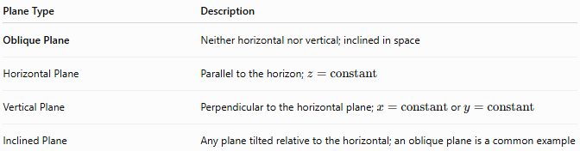
Plane Type | Description
Oblique Plane | Neither horizontal nor vertical; inclined in space
Horizontal Plane | Parallel to the horizon; $z=\text{constant}$
Vertical Plane | Perpendicular to the horizontal plane; $x=\text{constant}$ or $y=\text{constant}$
Inclined Plane | Any plane tilted relative to the horizontal; an oblique plane is a common example

Key Points
# Source: AI Source: Provided by: [Data Path: Persons Table -> ID Column: 1, Name_En Column: Motasem Essam] -> From: [ChatGPT] on [7/25/2026]
- An Oblique Plane is neither horizontal nor vertical.
- General equation:
$$Ax+By+Cz+D=0$$
- Normal vector:
$$n=\left\langle A,B,C\right\rangle$$
- It may intersect all three coordinate axes.
- It is commonly used to represent inclined surfaces.

Conclusion
# Source: AI Source: Provided by: [Data Path: Persons Table -> ID Column: 1, Name_En Column: Motasem Essam] -> From: [ChatGPT] on [7/25/2026]
An Oblique Plane is a plane that is inclined in space, being neither horizontal nor vertical. It is described mathematically by the general plane equation $Ax+By+Cz+D=0$ and has a normal vector that is not aligned with any single coordinate axis. Oblique planes are essential in analytic geometry, coordinate geometry, engineering, architecture, construction, surveying, CAD, robotics, physics, and computer graphics, where they are used to model and analyze sloped or tilted surfaces in three-dimensional space.

